Operators & Control Flow

- Operators
- Block Scope
- Conditional Statements
- Loops
- Determinate Loops
- Multiple Selections with switch
- Statements That Break Control Flow

- Operators
In programming, operators are the decision-making tools that allow a program to calculate, compare, and control values. Just like mathematical symbols guide humans in solving problems, Java operators guide the computer in performing operations and making logical decisions.
When a program receives data, operators determine how that data should be processed. They can perform calculations, compare conditions, combine multiple expressions, and control the flow of a program. Understanding operators is essential because almost every Java program depends on them to transform input into meaningful output.
Operators are special symbols or keywords in Java that are used to perform operations on variables and values. They allow programmers to combine, modify, compare, and manipulate data.
Java provides different types of operators, including:
- Arithmetic Operators: are used to perform basic mathematical calculations such as addition, subtraction, multiplication, division, and finding remainder
Operator | Purpose | Example
+ | Addition | 10 + 5 = 15
- | Subtraction | 10 - 5 = 5
* | Multiplication | 10 * 5 = 50
/ | Division | 10 / 5 = 2
% | Remainder (Modulus) | 10 % 3 = 1

- Relational Operators : are used to compare two values and return a Boolean result (true or false).
Operator | Meaning | Example
== | Equal to | 5 == 5 → true
!= | Not equal to | 5 != 3 → true
> | Greater than | 8 > 5 → true
< | Less than | 3 < 5 → true
>= | Greater than or equal | 5 >= 5 → true
<= | Less than or equal | 4 <= 5 → true
- Relational operators always return boolean.
- They compare values but do not change them.
- Commonly used for program decisions.
- Logical Operators: are used to combine multiple conditions and create complex decisions.
Operator | Name | Description
&& | Logical AND | True when all conditions are true
` |  | `
! | Logical NOT | Reverses the result
- Used heavily in decision-making.
- Helps combine multiple conditions.
- Produces Boolean results.

- Assignment Operators : are used to assign values to variables or update existing values.
Operator | Example | Meaning
= | x = 10 | Assign value
+= | x += 5 | Add and assign
-= | x -= 5 | Subtract and assign
*= | x *= 5 | Multiply and assign
/= | x /= 5 | Divide and assign
%= | x %= 5 | Modulus and assign
Used to store values.
Compound assignments reduce code length.
Automatically perform type conversion.

- Unary Operators: operate on only one operand.
Operator | Meaning
+ | Positive value
- | Negative value
++ | Increment by 1
-- | Decrement by 1
! | Reverse boolean value

- Bitwise Operators: operators perform operations directly on the binary representation of integer values. They work at the bit level (0 and 1).
Operator | Name | Description
& | Bitwise AND | Both bits must be 1
` | ` | Bitwise OR
^ | Bitwise XOR | Bits are different
~ | Bitwise NOT | Reverses bits
<< | Left Shift | Moves bits left
>> | Right Shift | Moves bits right

Think like a problem solver who controls decisions and transformations step by step. A programmer does not see operators as just symbols; they see them as tools for expressing intent, logic, and relationships between data. Arithmetic operators represent the idea of changing and calculating values, relational operators represent comparison and judgment, logical operators represent combining thoughts and conditions, assignment operators represent storing and updating decisions, unary operators represent small state changes, and bitwise operators represent controlling information at a deeper machine level. Expert programmers choose operators by first understanding what decision the program needs to make and how information should flow, then selecting the operator that most clearly represents that thinking.

- Block Scope
As programs become larger and more complex, it is important to organize variables so they are only accessible where they are needed. Allowing every part of a program to access every variable can lead to confusion, accidental modifications, and difficult debugging. To solve this problem, Java uses block scope, which defines clear boundaries for where variables can be declared and used. Understanding block scope helps programmers write cleaner, safer, and more maintainable code.

Block scope: is the region of a program where a variable is declared and can be accessed. In Java, a block (also called a compound statement) is a group of one or more statements enclosed within a pair of curly braces { }.

Variables declared inside a block exist only within that block and are automatically destroyed when program execution leaves the block.
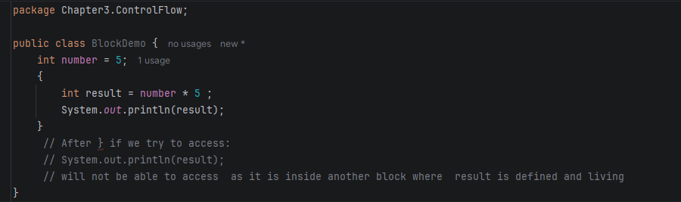

A nested block: is a block created inside another block. Each nested block creates its own scope while still being able to access variables declared in the outer block.
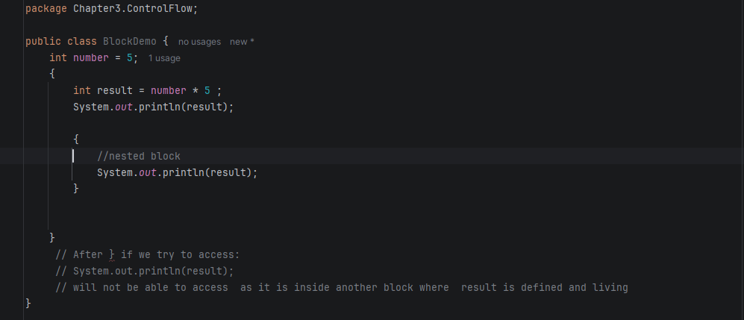
Java follows several rules for variable visibility:
- Variables are accessible only within the block where they are declared.
- Inner (nested) blocks can access variables from outer blocks.
- Outer blocks cannot access variables declared inside inner blocks.
- When execution leaves a block, all local variables declared in that block are no longer available.

Java does not allow a local variable to be declared more than once within nested scopes if it has the same name as an existing local variable.
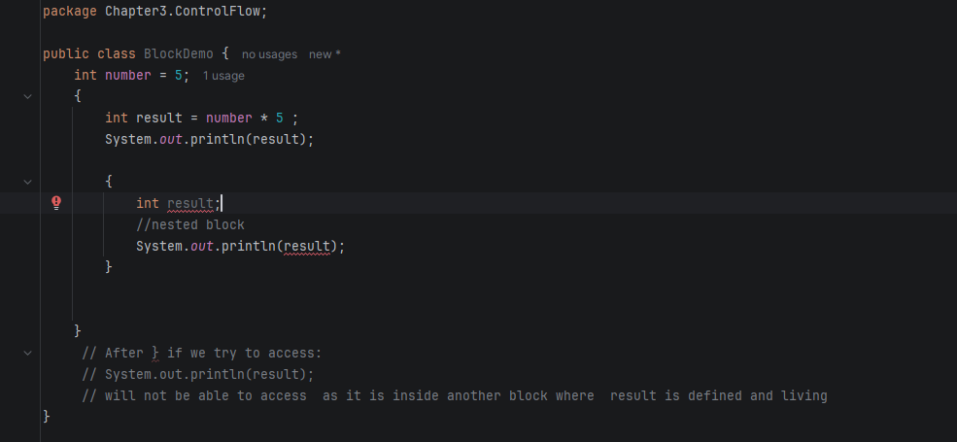
Block scope is an essential concept because it helps programmers:
- Control where variables can be accessed.
- Prevent accidental modification of data.
- Reduce memory usage by removing variables when they are no longer needed.
- Improve code organization and readability.
- Avoid naming conflicts between variables.
- Write modular and maintainable programs.
- Minimize programming errors caused by variable misuse.

view block scope as a way to limit responsibility. A variable should exist only for the task it performs and should not remain accessible after that task is complete. This practice follows the principle of least visibility, where every variable is given the smallest possible scope, making programs safer, easier to understand, and less prone to bugs.

